Before implementing reflector.p4:
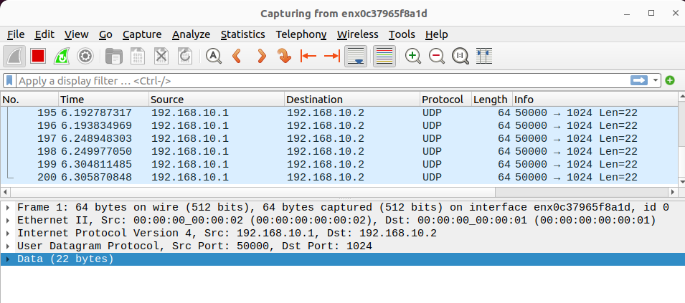

After implementing reflector.p4 :
table_add MyIngress.src_mac_drop MyIngress.drop 00:00:00:00:00:02 =>
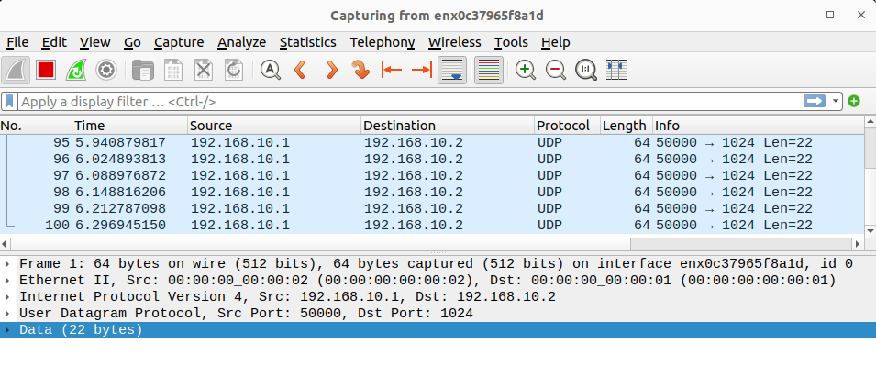
The number of packets has been halved as the source packets have been dropped.

Now using CWM to execute the swap command:
